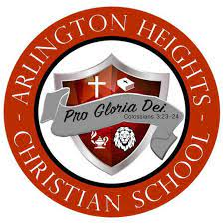

**Arlington Heights Christian School**

**Dove Hunt Raffle ($25 per ticket)**

Proceeds benefit AHCS Football

**Valued between $1,500-$2,000**



**Raffle drawing on Saturday, August 23**

**Event is for up to 20 people during the Fall South Zone Hunting Season**

**(no carry over to the following season)**

**Ranch located at 3000-3024 FM 796, Beeville, Texas**



**Contact Larry Sanchez 361-446-9708**